

Session: 2021 – 2025

**Submitted by:**

Abdul Mateen 2021-CS-190

Khadim Hussain 2021-CS-204

**Supervised By:**

Dr. Maida Shahid

Department of Computer Science

**University of Engineering and Technology**, **Lahore Pakistan**

Table of Contents

Introduction 3

Project Features 3

Use Cases 3

Class Diagram 3

Wire Frames 4

Technology and Resources 7

# Introduction

This Project is a web based Social Media Platform where you can add other people as your friend and share your beautiful memories with them. You can also view what they are doing in their life. You can share your review by liking and disliking there post. You can also message them and ask them how there life is going.

# Project Features

Most Important features are mentioned below:

* Post your Picture and Caption it
* Add Friends
* Like and Dislike Posts of others
* Message your Friends

# Use Cases

## SignIn/ SignUp

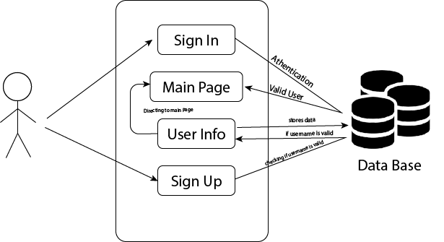

## Main Page

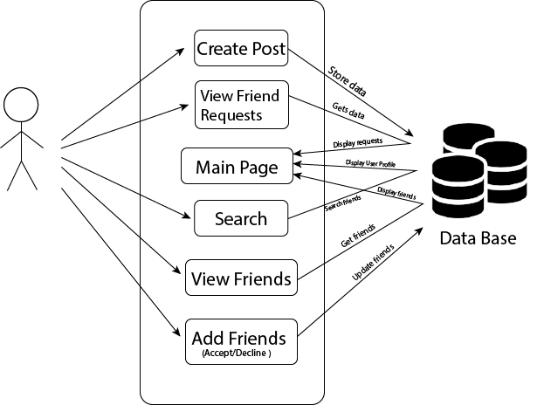

## Messages

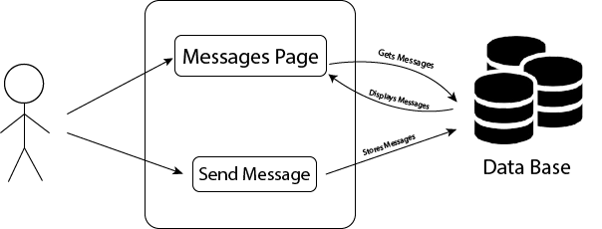

# Wire Frames

Login Page

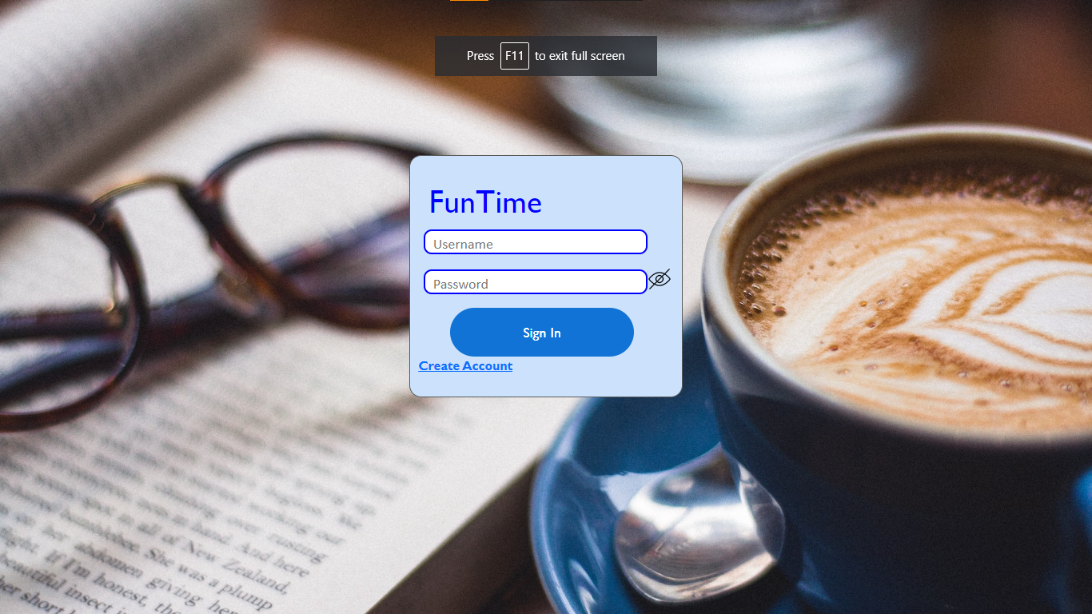

Sign Up Page:



Main Page:

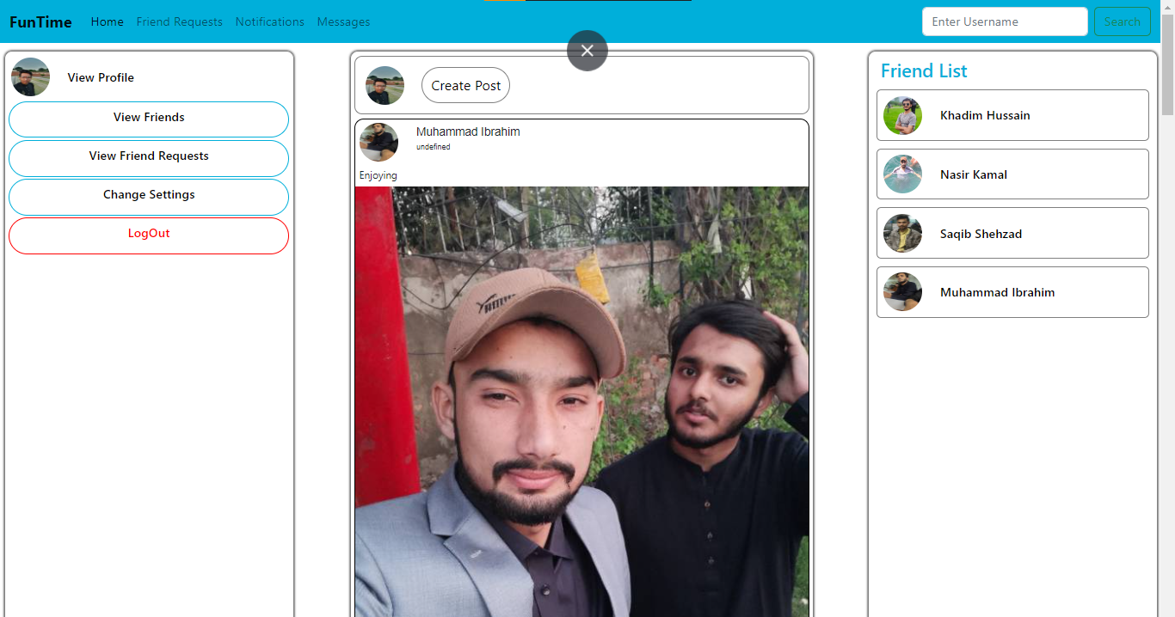

Create Post:

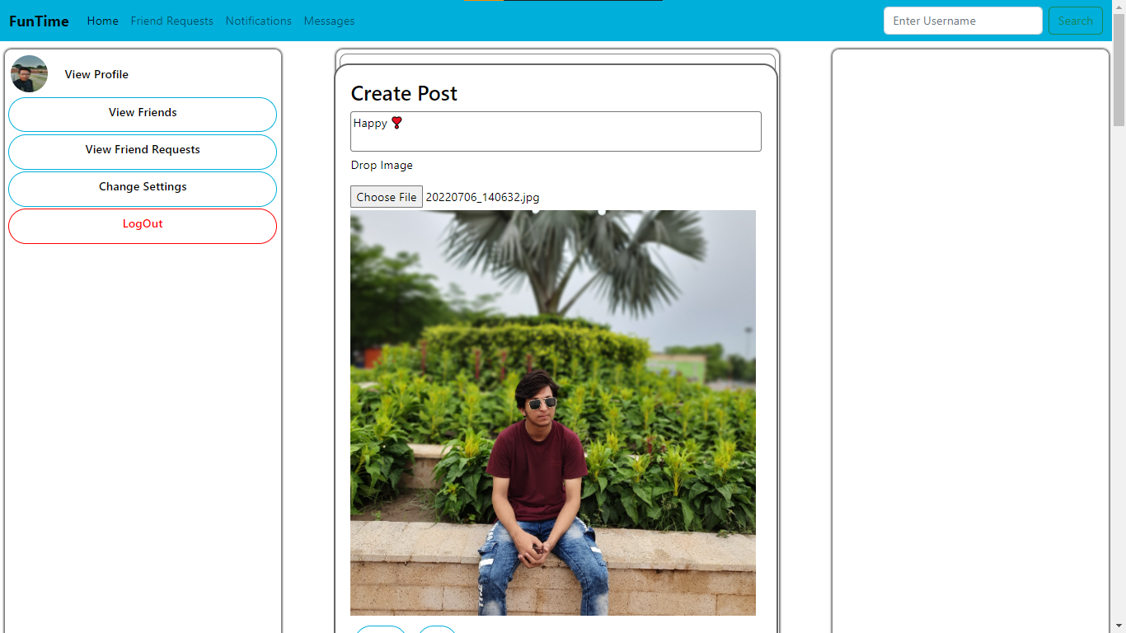

Friend Requests:

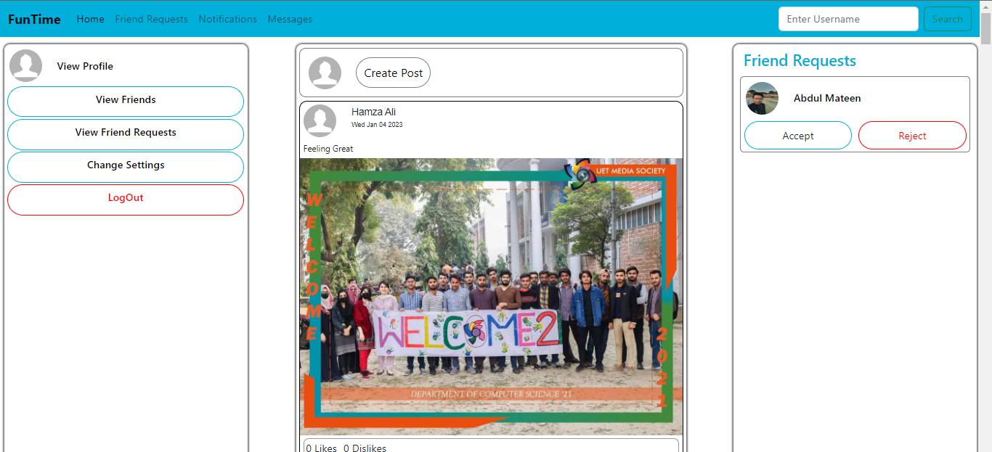

Messages:

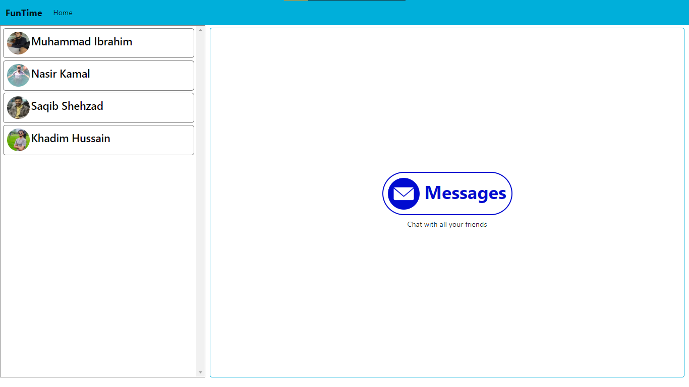

Change Settings

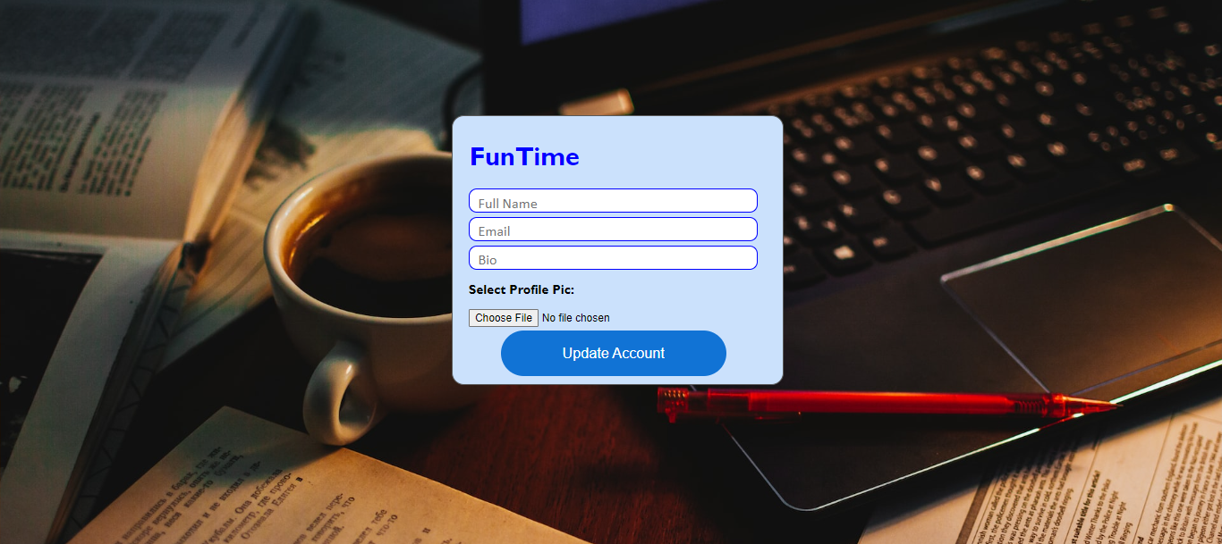

# Technology and Resources

This is web based project so we used

* HTML
* CSS
* JavaScript

The database we used to store data of users and their posts is Firebase Real-time database.